D1 Sensor Health
Final causal recovery method and expert validation report
Algorithm: 1.3.0-final-candidate
Run ID: d1-final-8fdd3599890f
Data scope: 14 DO/ORP scored channels; QR/QIR offline support only
Generated: 2026-07-21
Expert decision: The implementation is suitable as the locked final candidate for thesis and manuscript analyses. Its recovery claims are internally validated at the event level; diagnostic accuracy against maintenance truth remains an external-validation task.

1. Scope and non-overlap
D1 evaluates the health of each DO/ORP sensor from signal-health evidence. It is intentionally independent of D2 temporal availability, D4 physical-rate plausibility, D6 parallel-redundancy synchrony, and D7 topological representativeness. Section 1.1 provides the causal hourly preprocessing and residual basis; D2-D7 do not feed back into the D1 score.

2. Nine finalized revisions
# | Risk | Final resolution | Verification
1 | Metric definition | Event-level direct/adapted recovery; occupancy descriptive only | Episode table + KM
2 | Direct path | Six-hour confirmation after Refractory | Unit test
3 | Candidate path | 3 h entry; 12-of-18 h tolerant window; bounded soft/missing hours | Config + sensitivity
4 | Duplicate regime gate | Raw W1 removed as production hard veto | Variant A/B comparison
5 | New steady regime | Contextual local and peer residual evidence can authorize recovery | Stable-regime challenge
6 | Residual scale | Causal channel-specific empirical noise floor | Calibration audit
7 | Baseline causality | Past-only contiguous complete windows; no gap spanning | Unit test
8 | Event identity | Active-episode retrigger requires independent PELT evidence | Uniqueness + conservation
9 | Release evidence | Sensitivity, 14-channel challenges, hashes, source data, Nature figure QA | Release gate

3. Causal state model
State | Role | Exit logic
Normal | No active episode | Independent event evidence
Refractory | Suppress immediate drift reinterpretation | Direct recovery or baseline assessment
BaselinePending | Wait for a causal stable local window | Stable baseline or continued pending
SustainedAnomaly | Adapt within a persistent departure | Three consecutive recovery-gate passes
RecoveryCandidate | Accumulate tolerant 12-of-18 h evidence | Recovered or retry cooldown
Recovered | Monitor for 24 h | Normal or relapse

PELT evidence has an explicit availability time and signed magnitude. A new event ID cannot be created merely because a statistic fluctuates during an existing episode.

4. Formal run results
Metric | Result | Interpretation
Unique episodes | 22 | Opened event IDs
Direct recovery | 15 | Cleared after Refractory
Adapted recovery | 6 | Recovered via local contextual baseline
Superseded | 1 | Independent new event
Right-censored | 0 | Incomplete end-of-record follow-up
Event recovery rate | 0.9545 | Recovered / completed episodes
95% Wilson interval | 0.7820-0.9919 | Sampling uncertainty
Median recovery time | 53 h | Event onset to confirmation
Recovered occupancy | 0.21% | Observation-state occupancy, not recovery rate
Transition conservation | PASS | 22 opened = 22 episode records; no duplicate IDs

5. Recovery evidence
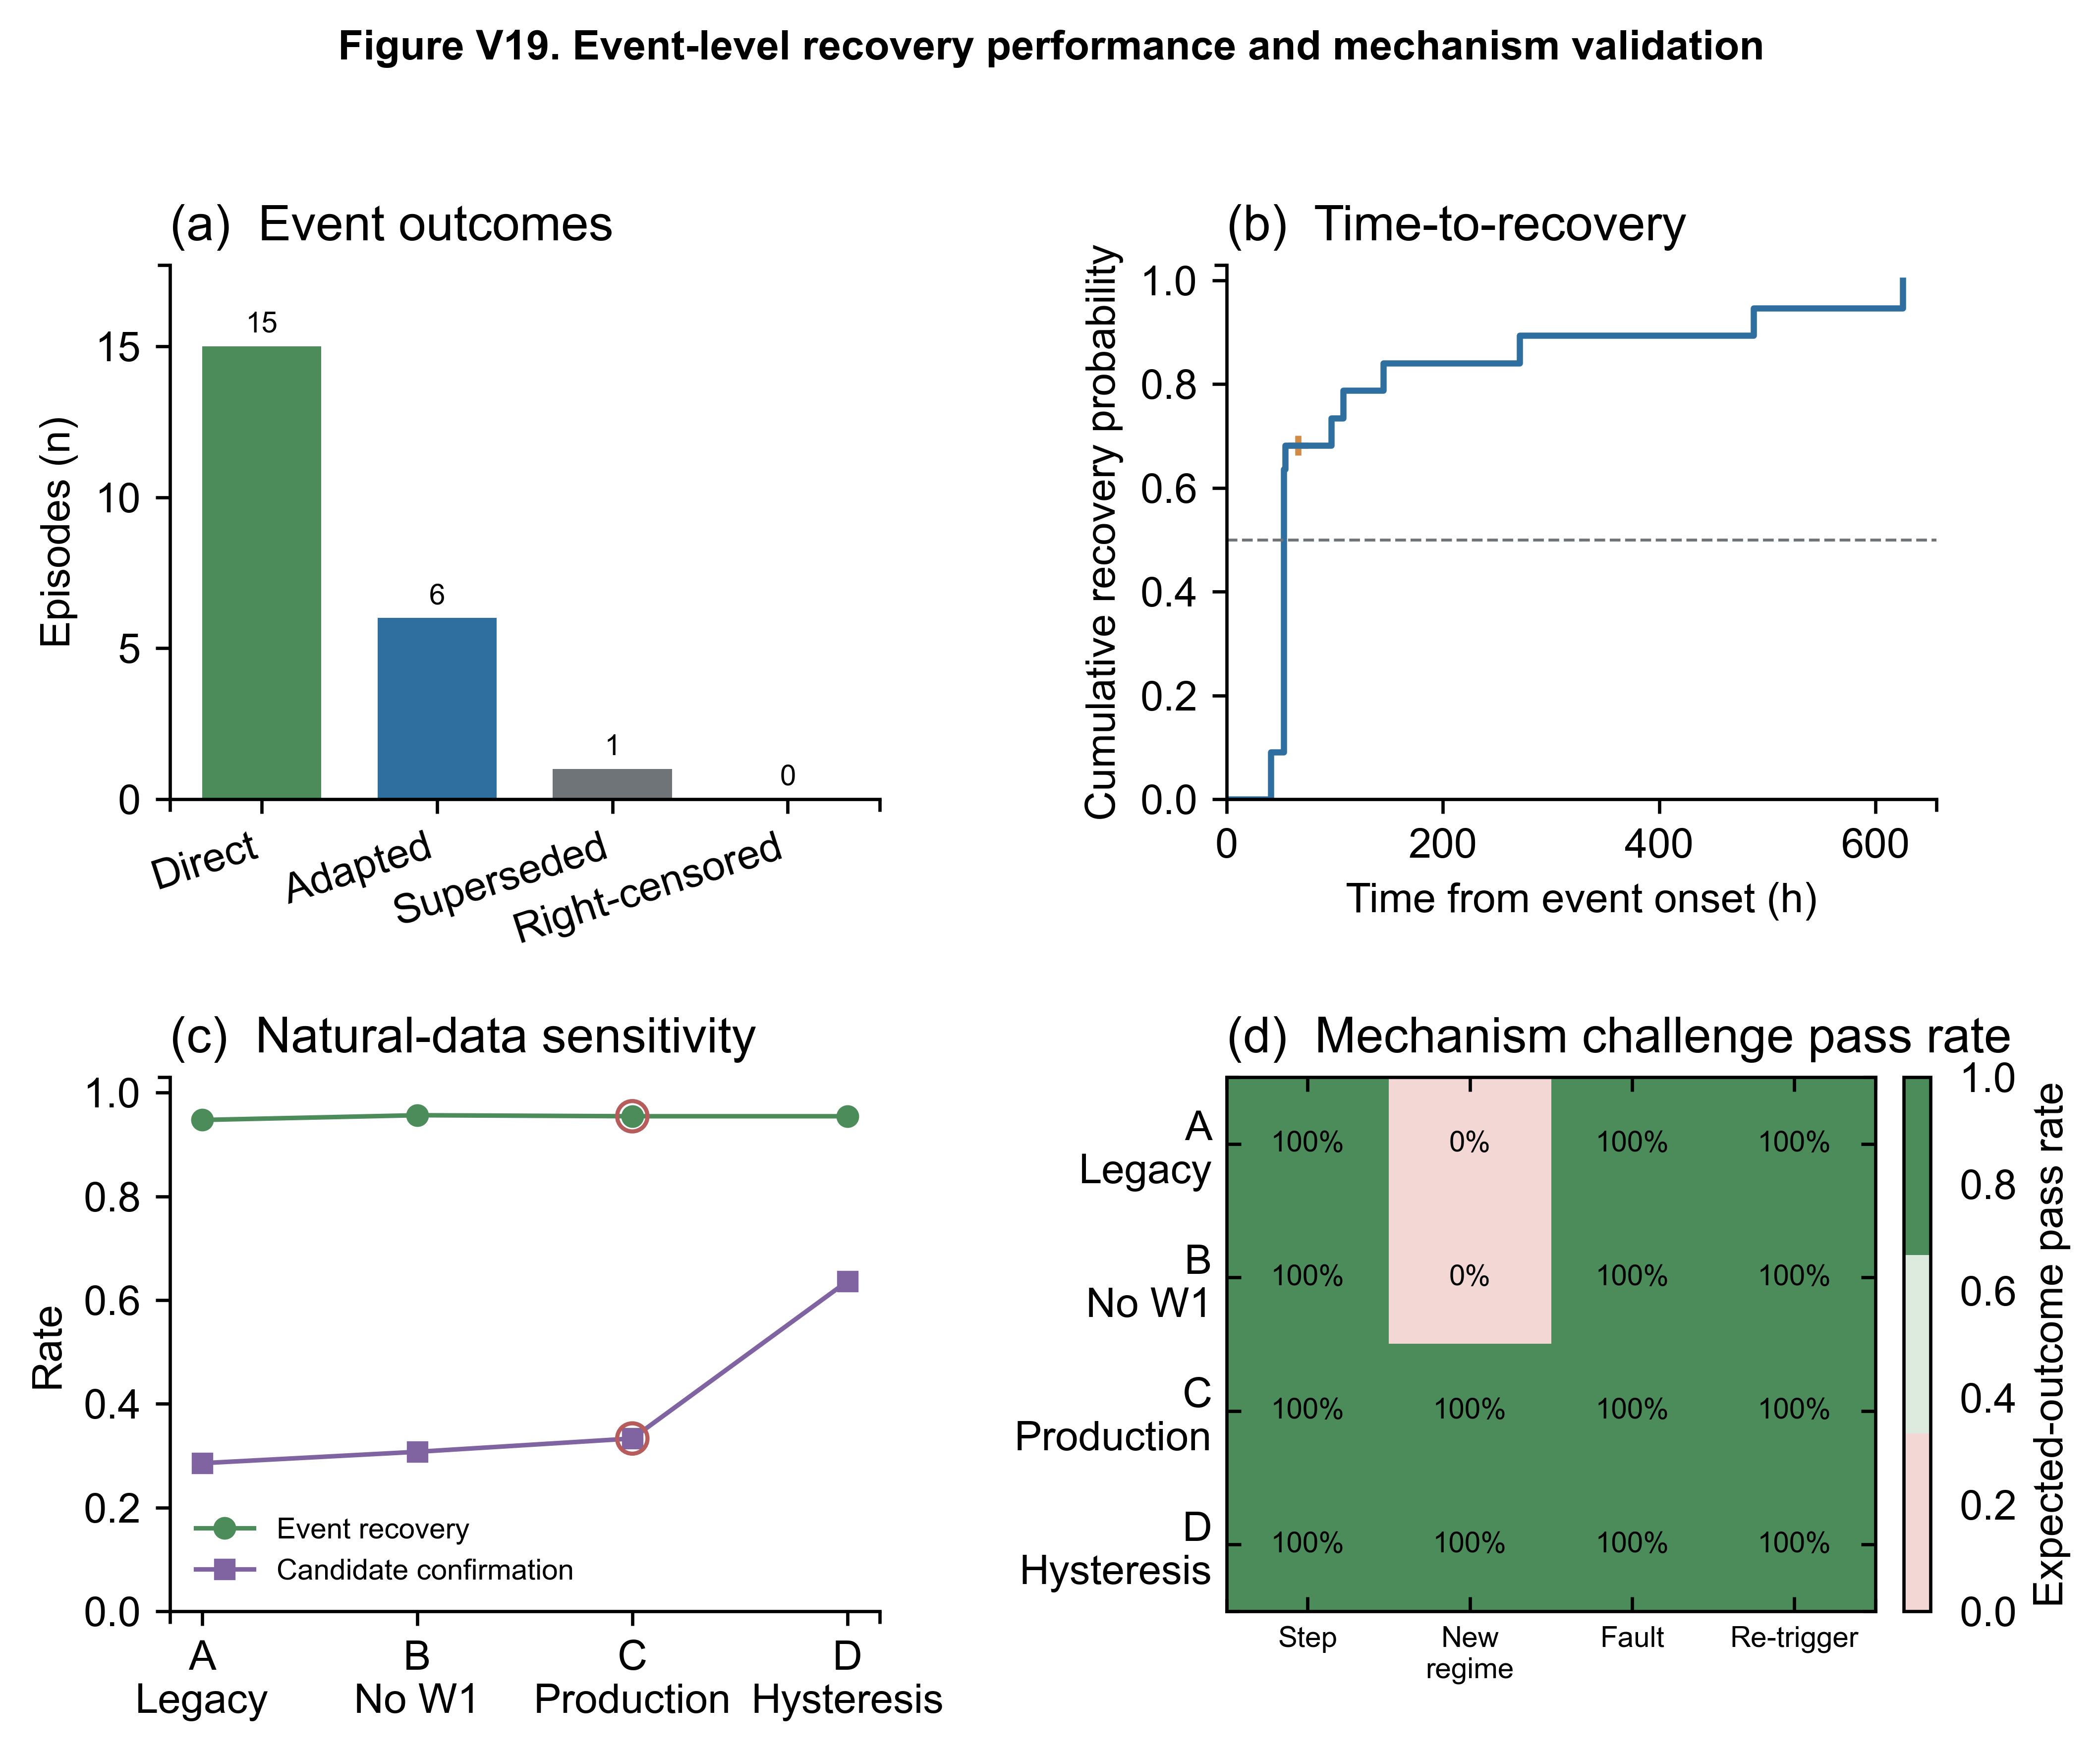
Figure V19. Event outcomes, recovery-time distribution, natural-data sensitivity, and controlled mechanism challenge results.
The low Recovered-state occupancy is expected because Recovered is a bounded 24 h observation state. It must not be interpreted as the proportion of successfully recovered events.

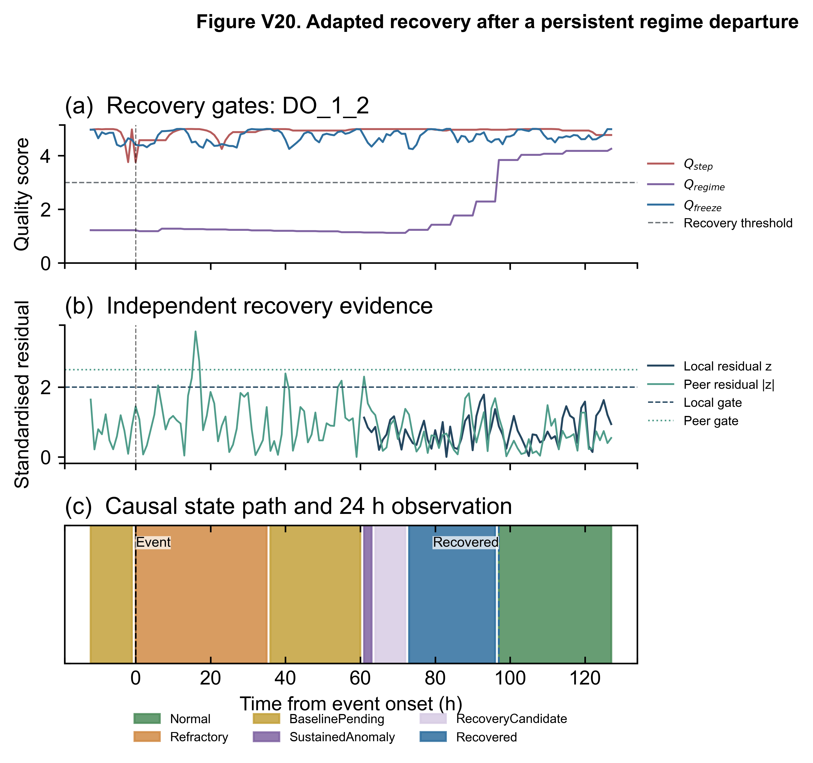
Figure V20. Representative adapted recovery after a persistent regime departure, including quality gates, independent residual evidence, and the causal state path.

6. Sensitivity and selected production rule
Variant | Event recovery | Attempts | Confirmation | Completed | Censored
A_legacy_gate_corrected_engine | 0.947 | 14 | 0.286 | 19 | 2
B_remove_duplicate_W1 | 0.957 | 26 | 0.308 | 23 | 1
C_tolerant_3h_retry12h | 0.955 | 39 | 0.333 | 22 | 0
D_hysteresis_6h_retry24h | 0.955 | 22 | 0.636 | 22 | 0

Production selection: Variant C passed 4/4 challenge classes across 14 channel-scaled templates with a pass rate of 1.00 in every class. Variant D was not selected because its longer entry and confirmation windows reduced candidate responsiveness without improving event recovery or controlled challenge outcomes.

7. Detector calibration, routing, and peer selection
The Step mapping is synchronized across mapping.yaml, the figure generator, and D1_mapping_params.xlsx: logistic k=16.0 and x0=0.55. The final D1 mean is 4.245 versus 4.254 for STRICT V1. Conservative caps apply only during causally defined non-normal states.
Component | Final rule | Audit evidence
DO_1_4 freeze | Process-floor route; production Q_freeze uses hard RLE only | Low variance and low uniqueness remain diagnostic fields
Step mapping | k=16.0; x0=0.55 | 10 iid channels; 780 scenarios; detection=0.867
Step applicability | Autocorrelation-aware and floor routes excluded from parameter fit | Theoretical corrected-KS bound retained in the audit
PLS peers | Forward blocks + block bootstrap + terminal test + four injection classes | DO_2_4 retains DO_2_3 (1 component); M1,1 median gain=-5.35% (95% CI -16.65% to 0.51%); terminal gain=-19.43%
ORP_1_2 platform | State cap retained | Fig. 7 exposes pre-cap score, cap-active hours, and final score

The PLS selector preserves a valid one-peer topology core and reports limited redundancy explicitly. It does not fill sparse peer sets by lexical order or with distant/cross-train channels. This removes the previous unsupported DO_2_4 links to DO_1_1 and DO_1_2. DO_2_3 is the structural core; DO_2_2 was evaluated as the only defensible second-order candidate but was not admitted. The one-component candidate had development and terminal-test gains of -5.35% and -19.43%, respectively; the two-component candidate was still weaker (-19.50% development gain). The formal decision is core_retained.
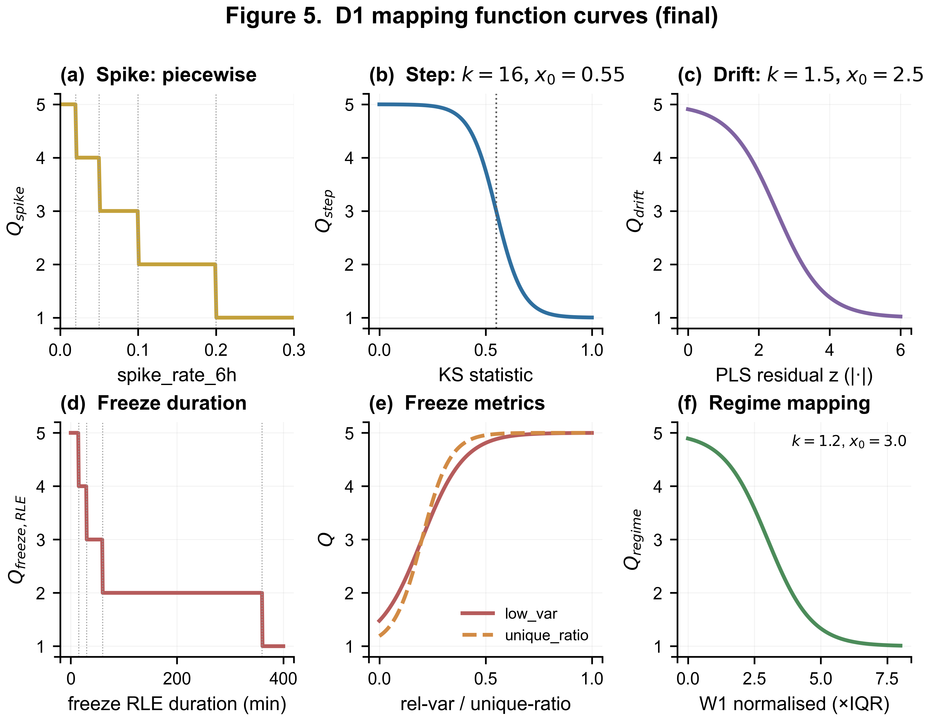
Figure 5. Final D1 mapping functions. The Step panel reports k=16.0 and x0=0.55.
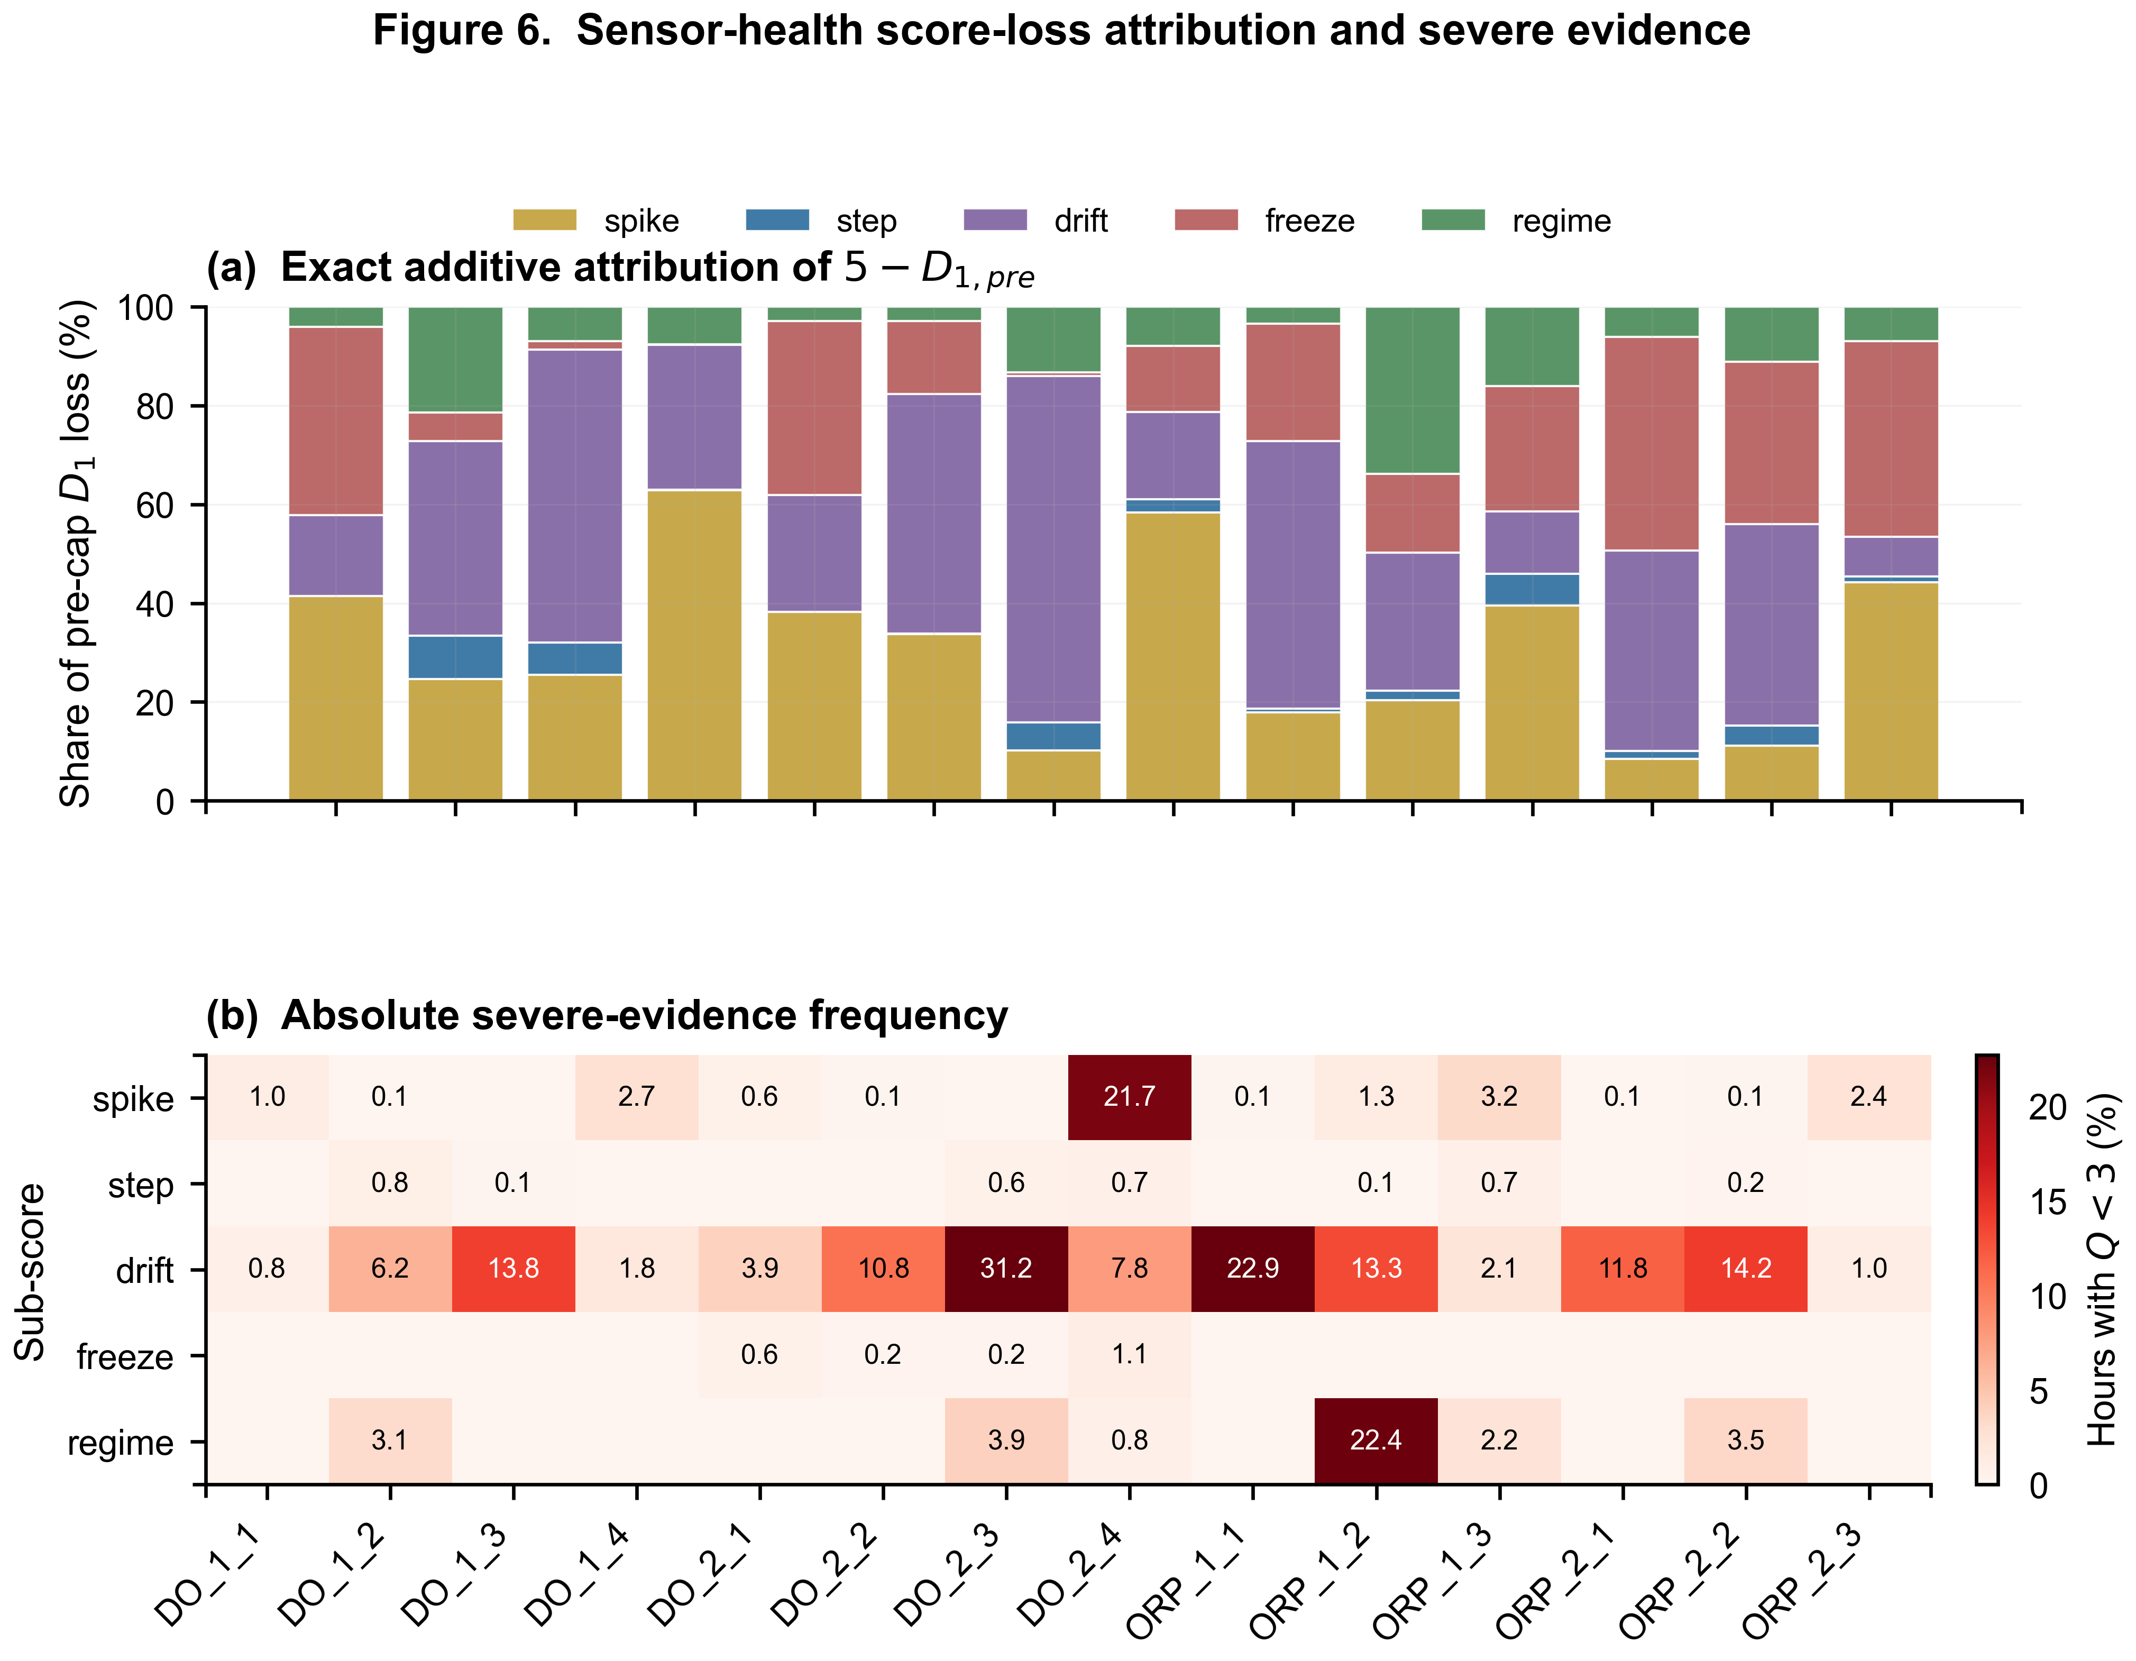
Figure 6. Exact pre-cap score-loss attribution and absolute severe-evidence frequency.
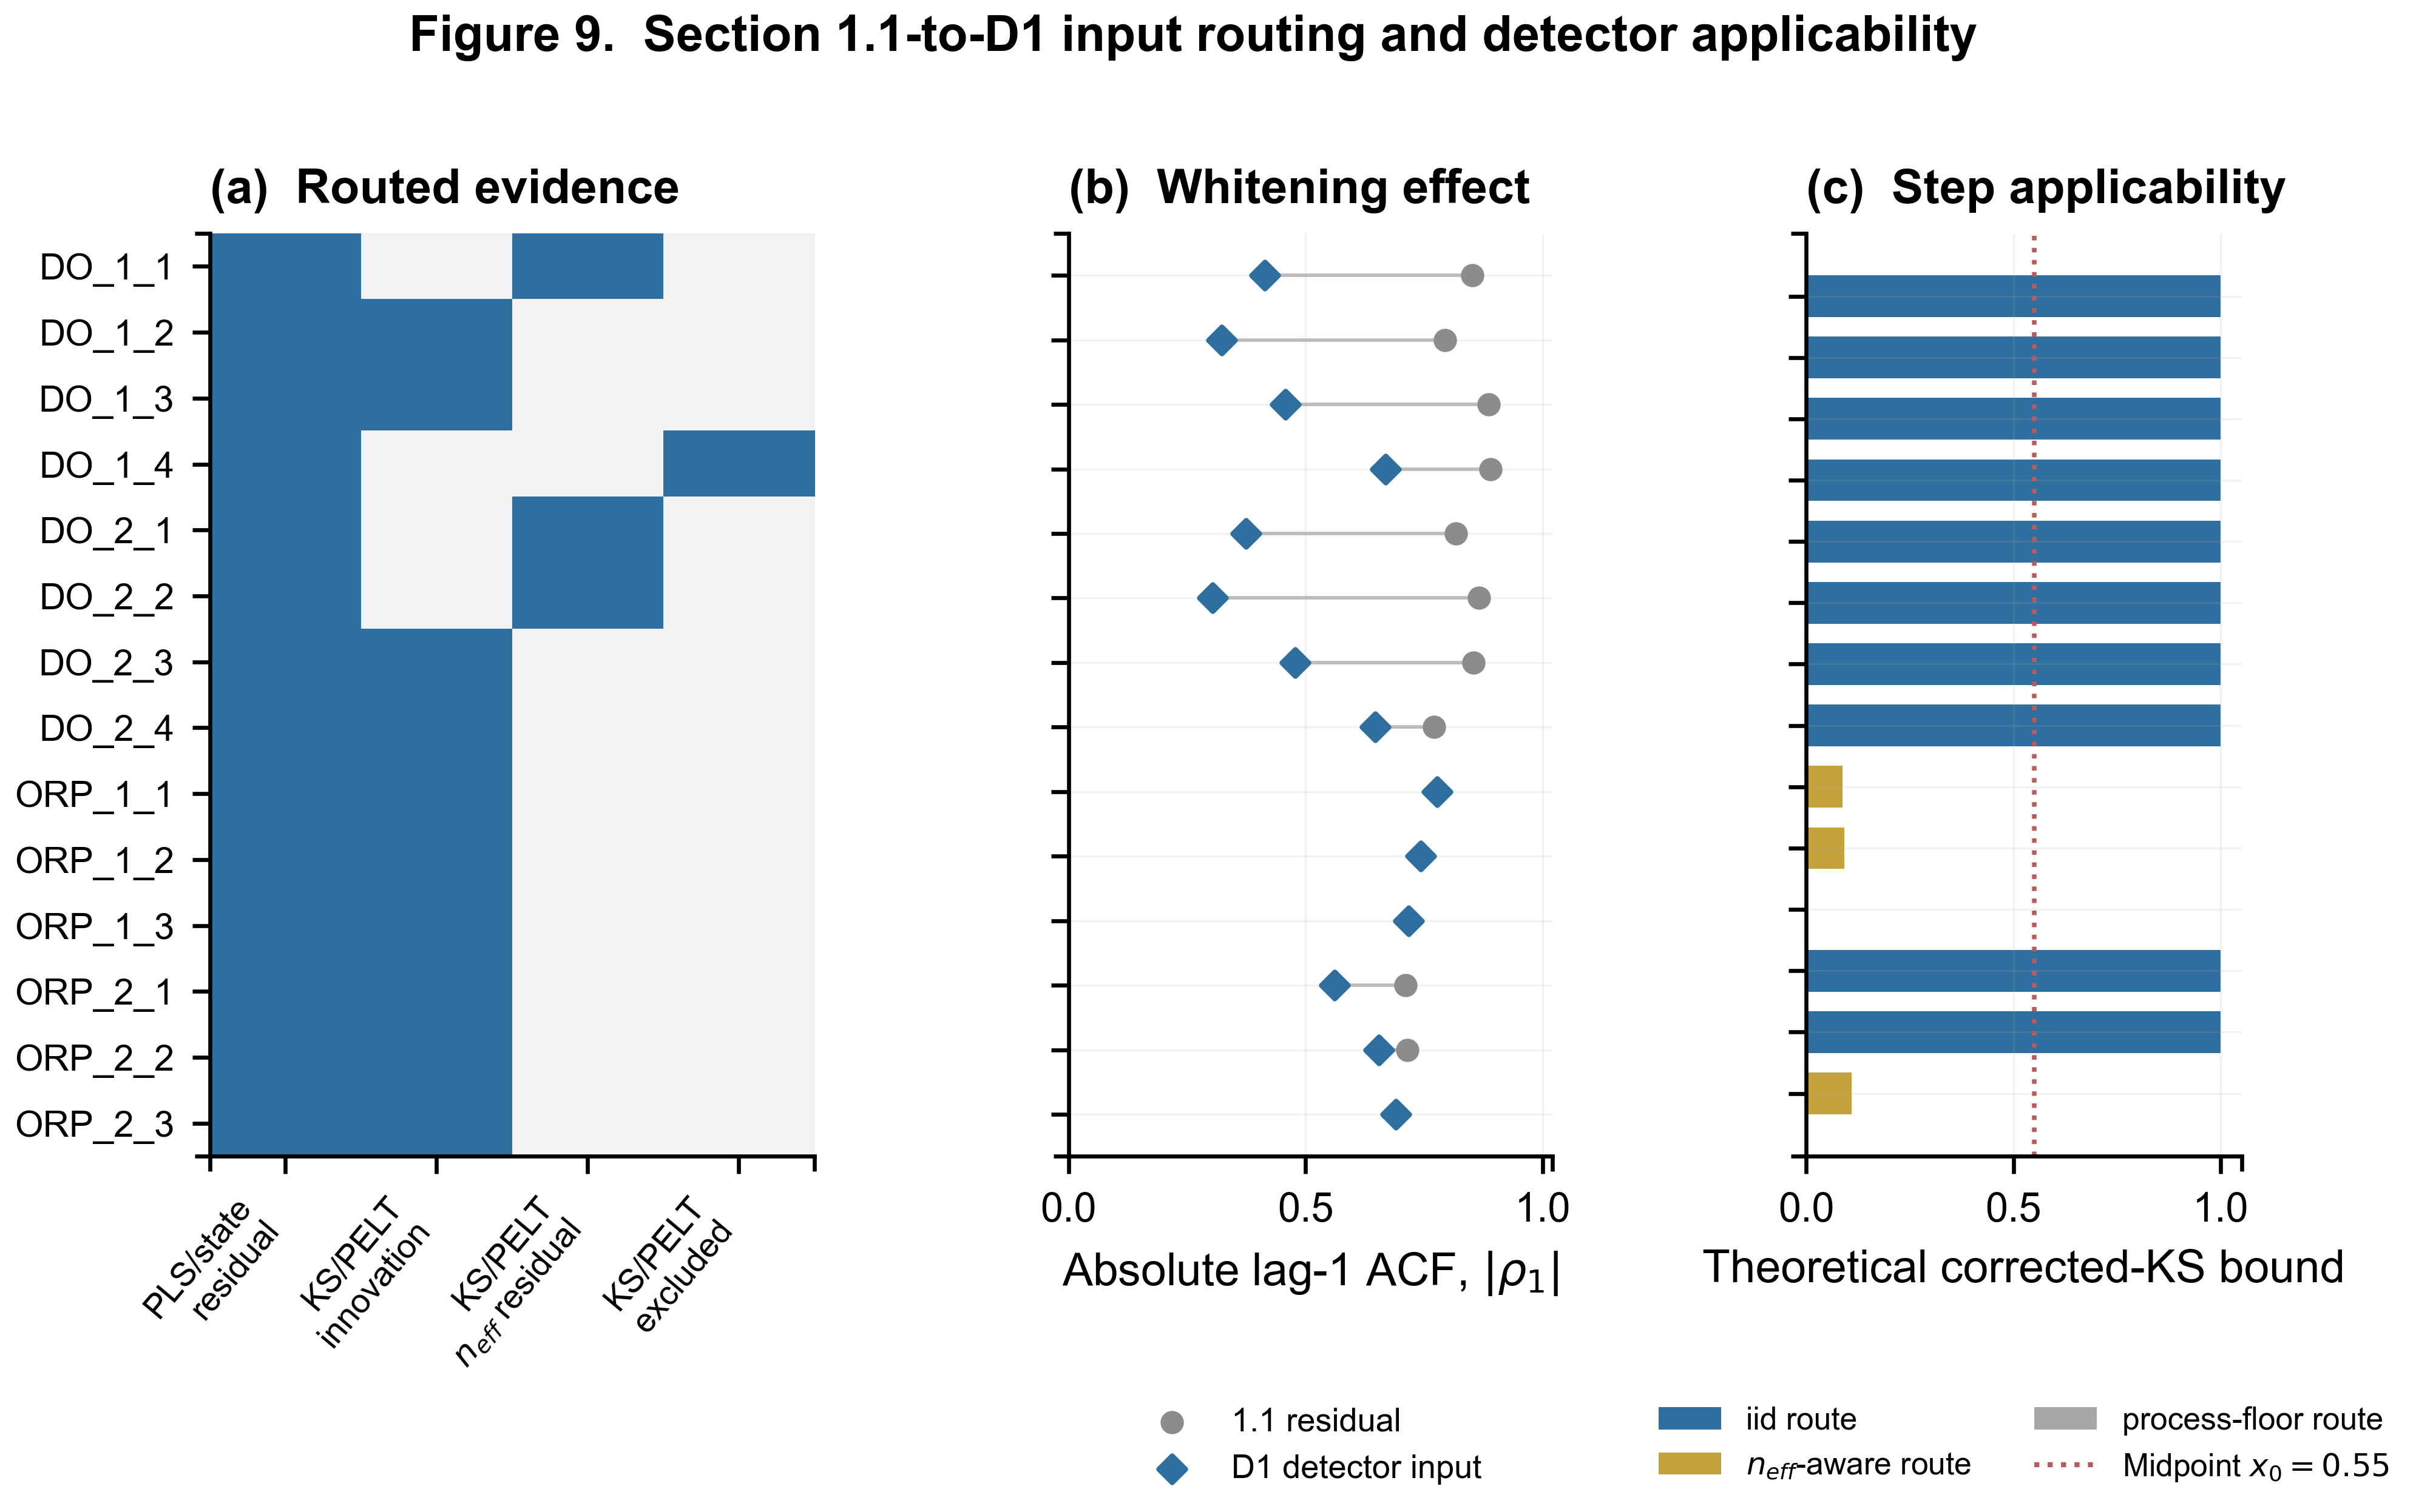
Figure 9. Section 1.1-to-D1 input routing, whitening effect, and Step applicability.
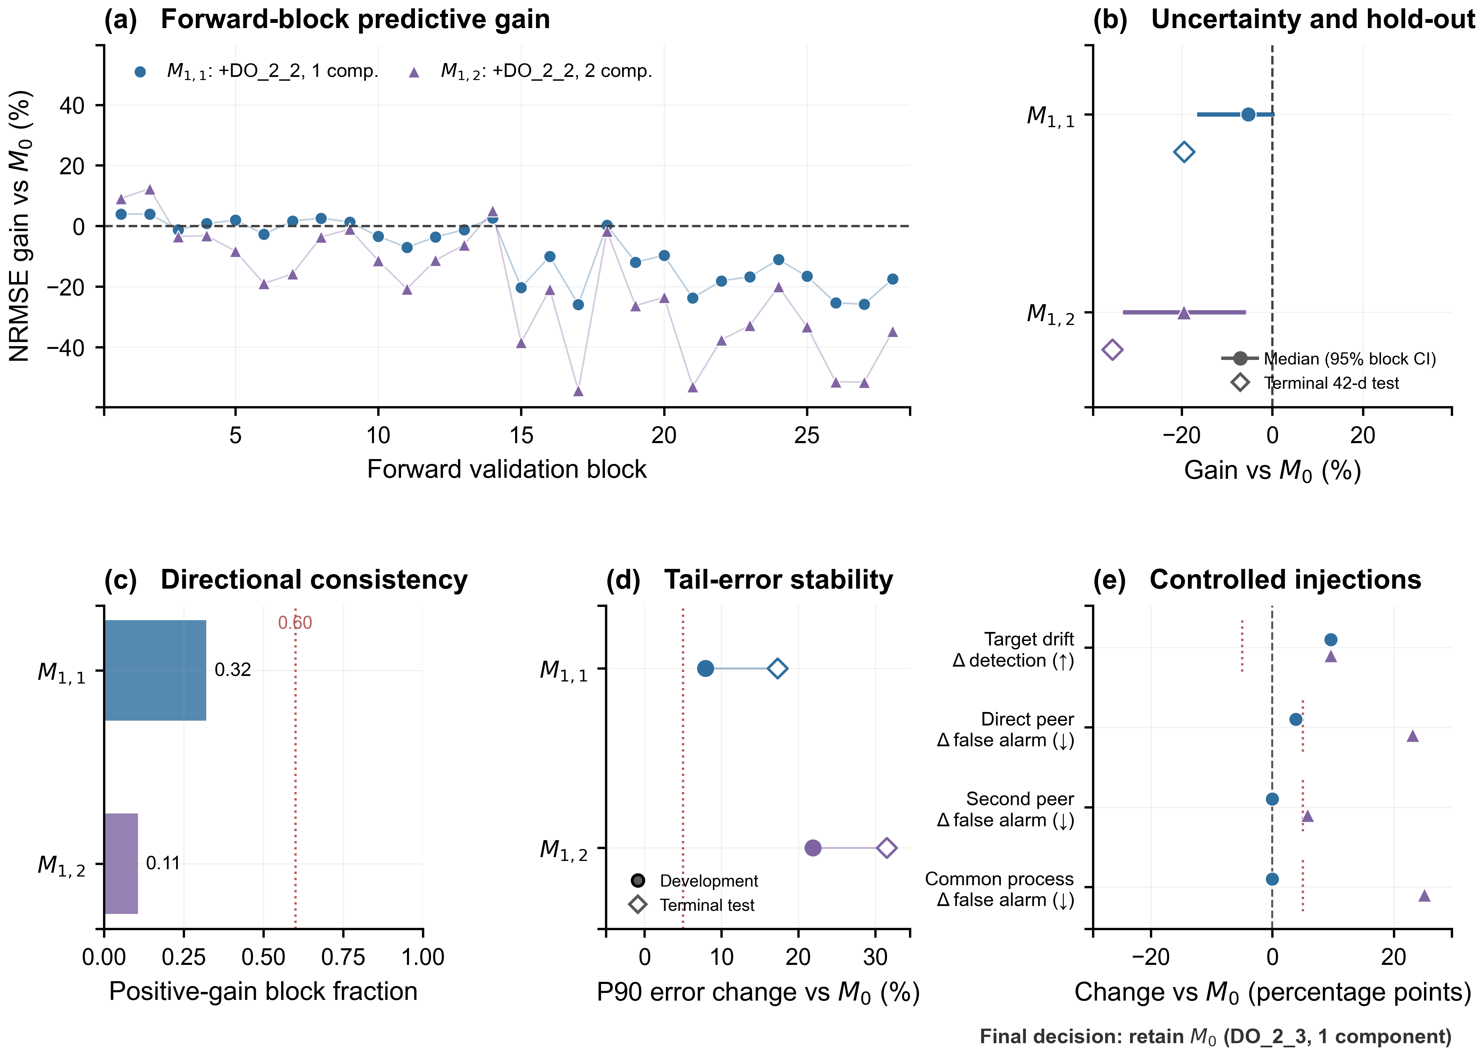
Figure 11. DO_2_4 PLS peer-admission evidence. Panels report forward-block gains, median and 95% moving-block-bootstrap intervals, positive-gain fractions, P90 tail error, terminal 42-day hold-out results, and controlled target/peer/common-process injections. The topology core M0 is retained.

8. Reproducibility and release gate
Gate | Result | Evidence
Unit tests | PASS | Causality, routing, mapping calibration, peer selection, recovery
Transition audit | PASS | All opened episodes accounted; all terminal or censored
Excel audit | PASS | 18 core / 20 total workbooks open; no error-cell tokens
Figure bundle | 20/20 | SVG/PDF/600 dpi PNG/TIFF
Nature skill audit | 0 failed | Editable SVG text; Arial declared; sources fresh
Run trace | d1-final-8fdd3599890f | Dependency SHA256 hashes in run manifest

9. Publication interpretation and limitations
The internal event recovery rate is not a labelled sensitivity/specificity estimate. No independently adjudicated maintenance or sensor-fault truth set is available. Controlled injections validate the recovery mechanism but do not replace an end-to-end detector benchmark under external sites, seasons, or maintenance interventions. The manuscript should report the Wilson interval, relapse rates, and these limitations.
Recommended external validation: blind maintenance-log adjudication; site-held-out evaluation; stratification by sensor type and operating regime; and prospective analysis of recovery time, false recovery, and relapse.

Appendix A. Authoritative artifacts
Role | Path
Configuration | configs/state_machine.yaml; configs/mapping.yaml
Formal state | v11_state.pkl
Run manifest | outputs/logs/D1_run_manifest.json
Recovery audit | outputs/data/D1_recovery_event_audit.xlsx
Sensitivity | outputs/data/D1_recovery_validation.xlsx
Step calibration | outputs/data/D1_step_mapping_calibration.xlsx
Figure source data | outputs/plot_data/
Figure QA | outputs/qa/figures/

